16.37: a) A frequency of 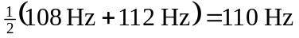will be heard, with a beat frequency of 112 Hz–108 Hz = 4 beats per second. b) The maximum amplitude is the sum of the amplitudes of the individual waves, 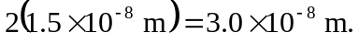 The minimum amplitude is the difference, zero.

